# Lab Exercise - Linux Firewall

|  |
| --- |
| * This is an individual lab exercise, and not graded. * The due date and time is tonight. * Change the file name following the usual naming convention. |

# Part 1 – Background on iptables

* Read the attached tutorials for details.
  + “IPTABLES Tutorial V1-3.pdf”
  + “iptables-091013105120-phpapp02.pdf”
* View the following video for the lab exercise below.

<https://www.youtube.com/watch?v=eC8scXX1_1M>

# Part 2 – Basic Commands & Use

* Basic commands to manage rules

# iptables -A Append to chain.

# iptables -F Delete all rules in chain or all chains.

# iptables -L List the rules in a chain or all chains.

# iptables -X [chain] Delete a user-defined chain.

# Part 3 – Exploring iptables

1. Determine the IP address of the host by using ipconfig.
2. Start the VMware Kali Linux guest and log in.
3. Determine the IP address of the Kali by using ifconfig.
4. On the Kali, enter the following command to list all the firewall rules: iptables –L
5. Provide a screenshot of your output.

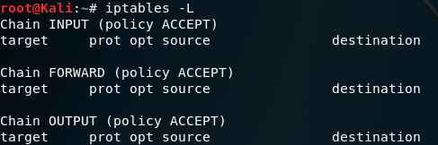

1. On the Kali, create a rule that blocks the ping requests from the host.
2. On the host, ping the Kali and take a screenshot of your output.

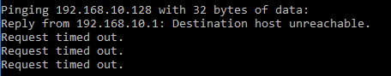

1. On the Kali, enter the following command to delete all the firewall rules: iptables –F
2. On the Kali, create a rule that blocks only the ping requests from the Kali.

C:\Users\Alex_Gudgel\AppData\Local\Microsoft\Windows\INetCache\Content.Word\ping 2.png

1. On the Kali, ping www.cnn.com and take a screenshot of your output.